**ORMAP Arrow Requirements (May 2020)**

**Feature Type**: Dimension Arrow Pairs, Label Arrows, Tics, and Hooks are line type features contained in the cartographic feature class.

**Elements**:

Dimension Arrow Pair: Dimension arrow pairs identify the end points of a measured and annotated line. Dimension arrows can be any height away from a line but typically have a standard measurement along the dimension line (eg: 1:400 scale map the dimension arrow Is 124’. Dimension arrows are always placed as a pair of matched features as illustrated below. Placement of arrow should be done with a minimum of clicks.

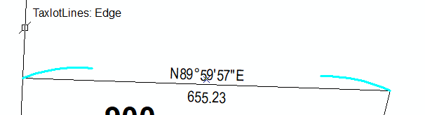

124’

Variable Height

1:400 Scale

Annotation Arrows: When a dimension does not fit within a space it can be placed away from the line it annotates and an arrow used to point at the feature. In addition, a number of features that are annotated such as taxcodes, taxlot numbers, subdivision names, and reference notes can all utilize arrow features to assist in clarifying what polygon or line a feature is associated with. Arrows can be straight, zigzag, or free format. Once an arrow is placed it must be able to be edited to be resized, rotated or reshaped.

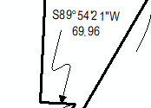

Land Hooks: Land Hooks are a pair of lines used to denote that two parcels of land are part of the same taxlot when they are separated by another feature such as a road or railroad right-of-way. Land hooks have a scale dependent size as illustrated below.

80’

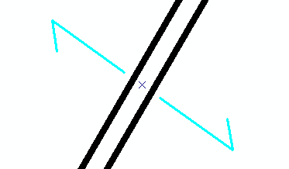

Road Tics: A road tic is denoted by a tic